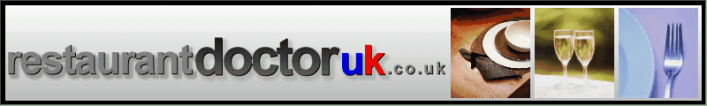

RESTAURANT CLEANING ROTA

DUTIES PER SHIFT | DAILY DUTIES | WEEKLY DUTIES | MONTHLY DUTIES
HOOVERING | CLEAN/POLISH CRUETS | CLEAN CHAIR BACKS | FULL CLEAN DOWN  OF ALL RESTAURANT AREAS
CLEAN/TIDY DROPS | CLEAN/POLISH VASES | POLISH WINDOWS | FULL CLEAN DOWN  OF ALL RESTAURANT AREAS
REMOVE DIRTY LINEN | POLISH BRASS | CLEAN/TIDY CROCKSTORE | FULL CLEAN DOWN  OF ALL RESTAURANT AREAS
CUTLERY | CLEAN/POLISH ENTRANCE | CLEAN BEHIND DROPS | FULL CLEAN DOWN  OF ALL RESTAURANT AREAS
CUTLERY/STARTER FRIDGE AREA | CLEAN HIGH CHAIRS | POLISH BRASS | FULL CLEAN DOWN  OF ALL RESTAURANT AREAS
COFFEE MACHINE | CLEAN/POLISH MIRRORS | SKIRTING BOARDS/DOOR FRAMES/DAIDO RAILS | FULL CLEAN DOWN  OF ALL RESTAURANT AREAS
Other | Other | PICTURE FRAMES | FULL CLEAN DOWN  OF ALL RESTAURANT AREAS
Other | Other | FIRE EXTINGUISHERS | FULL CLEAN DOWN  OF ALL RESTAURANT AREAS
SEE SEPARATE CHECKLIST |  | Other | FULL CLEAN DOWN  OF ALL RESTAURANT AREAS

THE ABOVE DUTIES MUST BE CARRIED OUT THOROUGHLY AND WITHOUT FAIL

